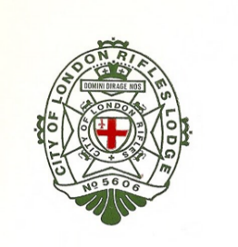
City of London
Rifles’ Lodge

No. 5606 (Consecrated 1936)

Part of the ‘ For the Fallen ’ Poem by Laurence Binyon  They shall grow not old, as we that are left grow old.  Age shall not weary them, nor the years condemn.  At the going down of the sun and in the morning  We will remember them.  Psalm 23  The Lord is my shepherd; I shall not want.  He maketh me to lie down in green pastures: he leadeth me beside the still waters.  He restoreth my soul: he leadeth me in the paths of righteousness for his name's sake.  Yea, though I walk through the valley of the shadow of death, I will fear no evil: for thou art with me; thy rod and thy staff they comfort me.  Thou preparest a table before me in the presence of mine enemies: thou anointest my head with oil; my cup runneth over.  Surely goodness and mercy shall follow me all the days of my life: and I will dwell in the house of the Lord for ever.  Poem by John Mcrea  In Flanders fields the poppies blow  Between the crosses, row on row,  That mark our place; and in the sky  The larks, still bravely singing, fly  Scarce heard amid the guns below.  We are the Dead. Short days ago  We lived, felt dawn, saw sunset glow,  Loved and were loved, and now we lie,  In Flanders fields.  Take up our quarrel with the foe:  To you from failing hands we throw  The torch; be yours to hold it high.  If ye break faith with us who die  We shall not sleep, though poppies grow  In Flanders fields. | Empty Chair Ceremony  4 November 2021  Deacons collect the symbolic representation of fallen Masons  Brethren come to Order with sign of Reverence  Deacons with the Entered Apprentice Apron perambulate to the Empty Chair  Brethren are seated.  Senior Warden Approaches the Empty Chair and places  Entered Apprentice Apron  Psalm 23  Poem by John Mcrea  Brethren come to Attention  Two Minute Silence  Last Post  ‘ For the Fallen ’ Poem by Laurence Binyon

